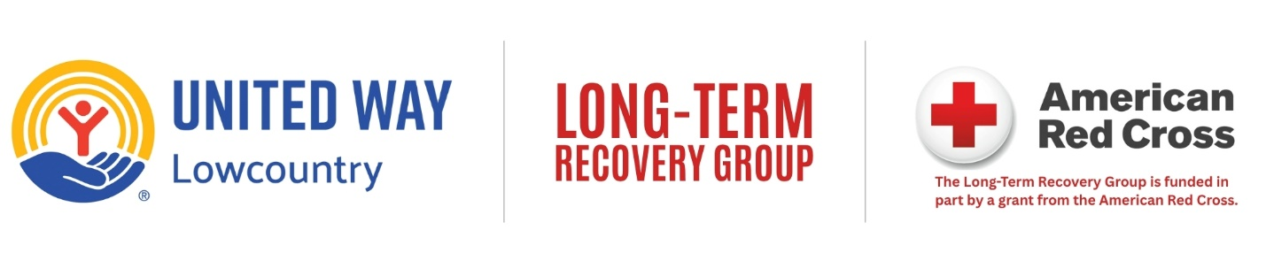
The UWLC Long-Term Recovery Group is a community network focused on helping Beaufort, Jasper, and Hampton Counties prepare for, respond to, and recover from weather disasters — starting with the ongoing needs of Hurricane Helene survivors.
We’d love for you to join us!
Why the LTRG?
The Lowcountry has a strong tradition of resilience, but disaster recovery is too big for any single organization. The LTRG brings together nonprofits, faith communities, civic groups, businesses, and government partners so that vulnerable residents get the support they need, when they need it.
About the LTRG
Launched in August 2025 with support from the American Red Cross, the LTRG supports post-Hurricane Helene recovery and builds readiness for future weather events. Current partners include:
American Red Cross • SC Office of Resilience • Team Rubicon • Presbyterian Disaster Recovery • Lutheran Church Service • Catholic Charities • Beaufort Jasper Housing Trust • Habitat for Humanity • Crisis Cleanup
… and many more local faith-based and nonprofit partners.
What You Get
- Better communication and coordination before, during, and after emergencies
- Access to shared resources and community expertise
- Clearer roles that reduce duplication and fill gaps in services
- Stronger relationships in both “blue sky” (everyday) and “grey sky” (storm and recovery) times
- Training, preparedness planning, and learning from local and national best practices
Your organization matters to this community, and your experience will make the LTRG stronger. We hold regular in-person meetings and would love to see you there.
Questions? Reach out to Kate Gill, 843-941-5042, or email ltrg@uwlowcountry.org.

